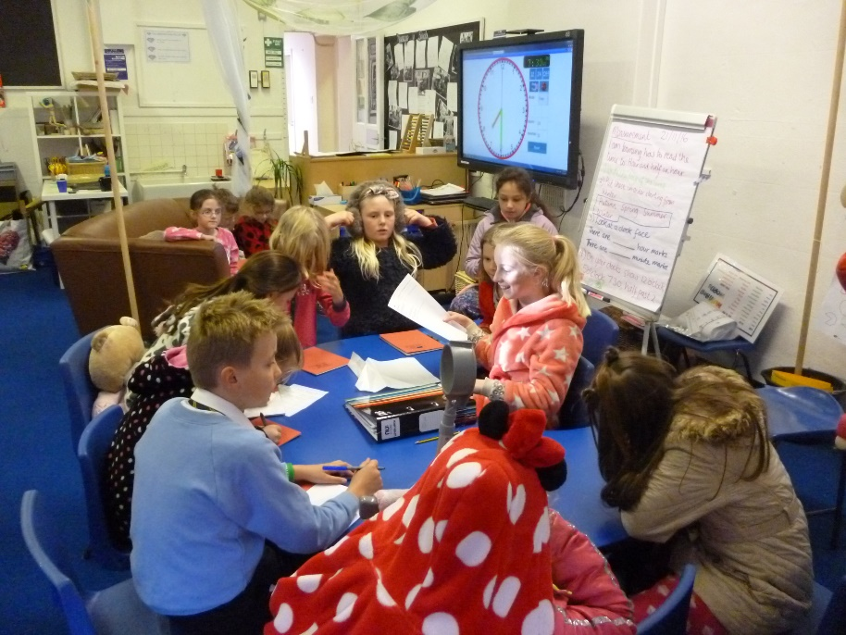
School Council November 2016

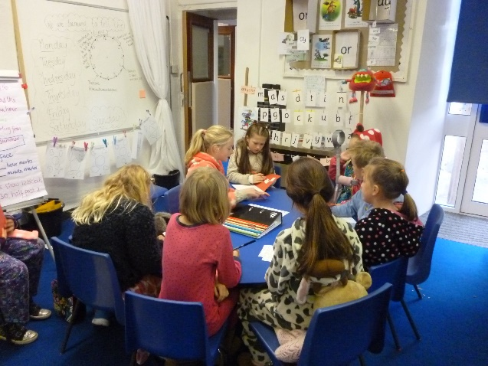
Maddie, School Council Chair leads the weekly meetings, whilst the Secretary and Vice Secretary, Amy and Riley take notes. Councillors report back on previous tasks and decisions are made. Currently on the agenda is the Christmas Fair, improving the toilets, healthy eating and improving the playground using money raised by School Council last year. Quite a lot of responsibility! So far this year we have held a ‘Pyjotty Day’ for Children in Need.
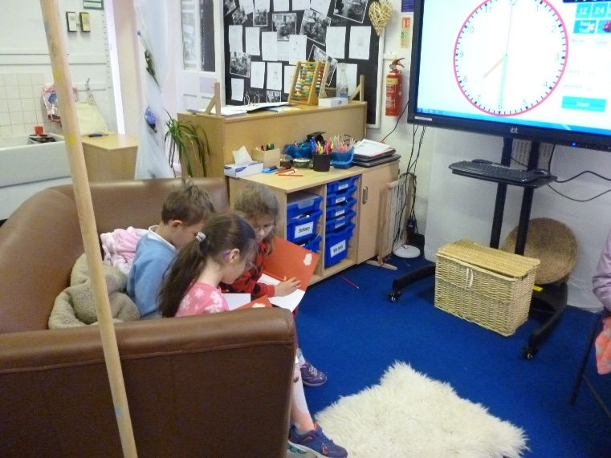
Class 2 Councillors are the KS1 liaison Officers and Publicity Officers. Our Council is made up of children from Y2 – Y6.
We also have a lot of regular visitors to School Council meetings who don’t have specific jobs but like to help out and join in.
We are a very strong and committed School Council, where children’s voices are heard and bring about change.

