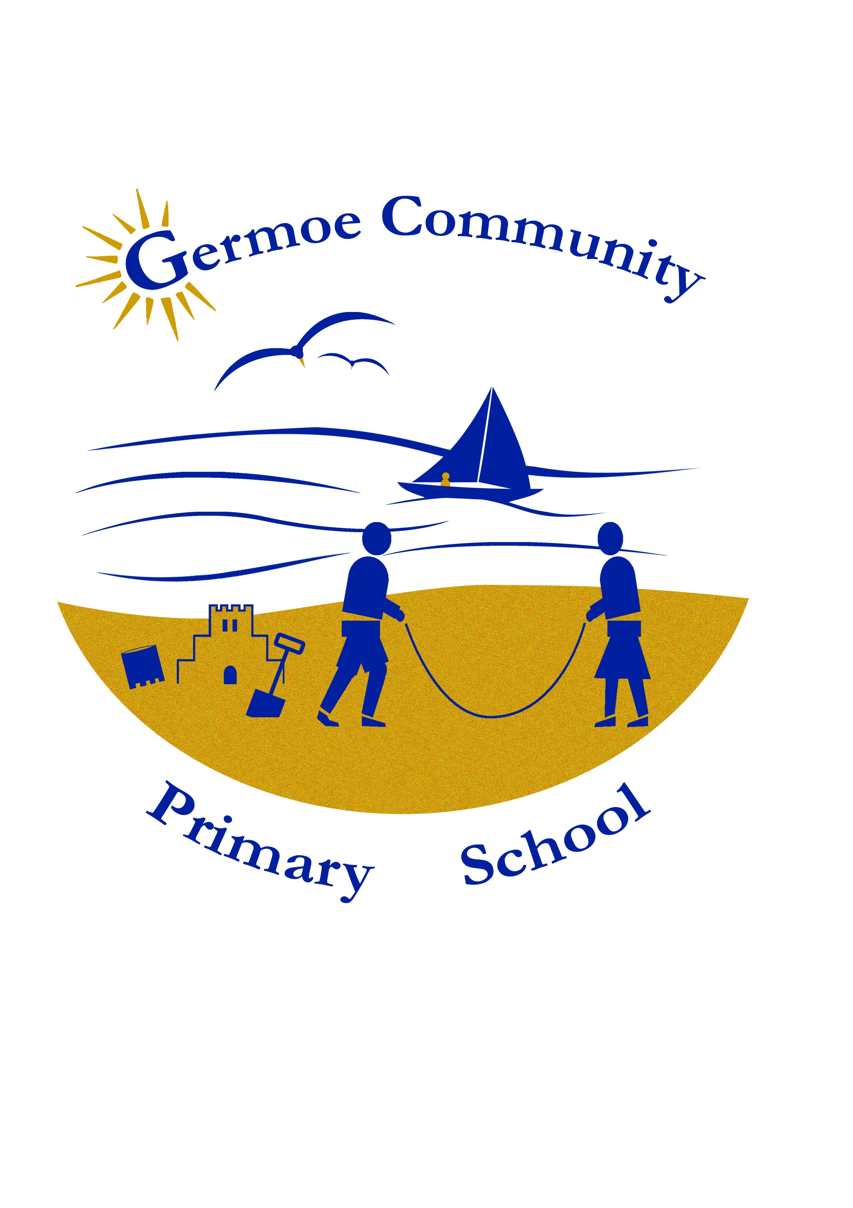
Germoe Primary School
Our ‘Local Offer’ for Special Educational Needs and Disability (SEND)
(Agreed by staff and governors July 2017)
Germoe Primary School is a small village school with an inclusive ethos and we pride ourselves on the efforts we make to ensure every child can access the curriculum, extra -curricular activities and outside visits.

We aim to meet the individual needs of all our children through quality first teaching. We aim to identify additional needs early and offer a range of intervention programmes targeted to meet the additional needs of the individual and groups. Some of our staff are Team Teach trained.

We can offer excellent pre-school provision, small class sizes and highly motivated teachers and support staff. We have engaging indoor and outdoor space, a field, wood and beach close by to enhance our learning and inspire discovery and investigation.

We work closely with outside agencies to ensure every child has what they need to support their learning and progress.

We have an excellent outdoor environment with climbing equipment, climbing wall, sports areas, garden, field and and our Forest School is a highly beneficial addition to the curriculum.

We are developing an inquiry approach to learning and our children are supported by a strong learning ethos. The children are immersed in a culture of collaborative learning, where they learn about themselves as learners. Our children develop resilience, both academically, emotionally and socially, they grow into being reflective learners, are resourceful and are able take risks which extends their learning and confidence.

We offer Wrap Around Care through our after school clubs, some of which are shared with Boskenwyn Primary School. We have strong community links, as well as working in close partnership with Boskenwyn School and the Helston and Lizard Peninsula Trust. Enhanced transition is offered to our most vulnerable pupils moving to secondary school.

We offer specialist PE and music tuition with advanced skilled teachers.

We value the Arts and offer children opportunity to experience live performances at both the Hall for Cornwall and the Minack Theatre. We take part in community events, often sharing in festivals in conjunction with Boskenwyn.

We would always recommend that you speak to your child’s class teacher with any concerns but other people you may wish to contact are:

Headteacher | Special Educational Needs Co-ordinator | SEN Governor | Nursery Teacher
Mrs Paula Quinney | Mrs Angie Larcombe | Mrs Tracy Stevens | Miss Jan Burns

Link to Special Educational Needs Policy
www.germoe.cornwall.sch.uk
Link to Equal Opportunities and Anti-Discriminatory Policy
www.germoe.cornwall.sch.uk
Link Equality Act & Accessibility Plan
www.germoe.cornwall.sch.uk

…………………………………….

The levels of support and provision offered by our school

- Listening to and responding to children and young people

Whole school approaches  The universal offer to all children and YP. | Additional, targeted support and provision | Specialist, individualised support and provision
- The views and opinions of all students are valued  - Termly questionnaire completed by all pupils  - Student voice is heard through School Council  - Small classes provide opportunity for regular conversation  - Regular Circle Time/ PSHE activities as needed  - After school clubs requested by children and support small group social and emotional development  - Pupil conferencing for academic and children’s emotional/social development  - Good provision for pastoral care for children, parents and carers  - Thrive Practitioner and school ethos supportive of Thrive Approach | - Students with SEND are included and valued  - Small group consultation opportunities are given to encourage all to contribute | - Student voice is integral part of SEND reviews and all meetings  - Opportunity to revisit events with trusted adult/mentor  - Nominate a child’s advocate for those children with complex and/or care needs  - Assisted technology to ensure those children with communication needs can be heard.  - Mental and emotional support via coaching and talking and drawing therapy

- Partnership with parents and carers

Whole school approaches  The universal offer to all children and YP | Additional, targeted support and provision | Specialist, individualised support and provision
- All parents and carers are actively encouraged to work in partnership with school.  - There are numerous events throughout the year when families are invited to come to school and join in celebrating the children’s achievements.  - Termly progress meetings are held with the class teacher but staff are happy to talk to parents and carers at other times throughout the year – we have an ‘open door policy’  - Home school reading diaries provide a vehicle for daily communication.  - Parents are encourage to speak to the class teacher but will be directed to other significant members of staff should the need arise.  - Annual end of year reports are sent home.  - Annual Pupil Premium reports are sent home.  - Information sessions such as E Safety.  - Regular communication via the newsletter of any SEND specific training for parents or parenting help. | - Individualised home school communication book.  - Families are encouraged to attend information sessions relevant to parenting skills, supporting children with homework etc. | - Parent/carer knowledge of their child’s strengths and interests as well as difficulties are valued and used to plan provision for the child.  - Parents/carers views are an integral part of any SEND reviews and meetings.  - Parents/carers are offered support with any parental contribution and accessing documentation as required.  - Parent/carers are encouraged to access support from outside of school via the Family Information Service, supported by the school Senco if an assessment by the Local Authority is undertaken.

- The curriculum

Whole school approaches.  The universal offer to all children and YP | Additional, targeted support and provision | Specialist, individualised support and provision
- The curriculum is designed to ensure all children can be included.  - Children’s interests and suggestions are built into the two year rolling programme.  - All children have access to the curriculum with reasonable adjustments made as required.  - We offer a broad and balanced curriculum with opportunity to widen experience, develop life skills, raise self-esteem and raise aspiration.  - Barriers to achievement are identified early to allow effective provision to be put in place.  - We value and promote trips, visits and enrichment activities to enhance our children’s interest and engagement in their learning  - Enquiry based approach to topic work and some other areas of the curriculum  - Continuing professional development including research for enhancing teaching and learning, visits and immersion supporting focus on educational improvement | - Children access curriculum enrichment opportunities.  - Nurture Group Provision  - Intervention packages are needs led and are adapted to meet the needs of individuals and groups of children.  - Intervention tracking monitors progress of those children at risk of making less than expected progress.  Small group intervention includes:  - phonics  - reading comprehension  - spelling  - numeracy  - fine motor skills/handwriting  - speech and language  - social communication  - keyboard skills | - Children with SEND can access the curriculum with adult support or modification as appropriate.  - Specialist advice is sought and recommended equipment and resources are used as directed to ensure access eg radio system for a child with a hearing impairment.  - Children‘s interests and strengths are used to encourage engagement in their learning.  - In exceptional circumstances children can be dis-applied from some aspects of the curriculum. This must be agreed by all involved.  - Individual curricula are implemented to address the needs of individuals where applicable.
- Teaching and learning

Whole school approaches  The universal offer to all children and YP | Additional, targeted support and provision | Specialist, individualised support and provision
- Well planned lessons with differentiated learning objectives and success criteria  - Needs led in-class TA support.  - In-class targeted teacher support as required.  - Access to visual aids and modelling  - Whole class visuals such as timetables  - Use of writing frames  - Access to ICT  - High level questioning  - Effective feedback face to face and through marking  - Preferred learning styles  - Alternative ways of recoding are used  - Effective challenge by use of varied pitch and pace  - Hands-on and real life experience  - Inquiry based learning approach  - Outdoor learning  - Embedded Growth Mind-set and Building Learning Power ethos develops strong and reflective learners | - Teachers and Support staff work in partnership, sharing information to ensure provision is effective and targeted appropriately.  - Access to needs led small group intervention for reinforcement of concepts requiring overlearning and/or pre-teaching of new concepts. This may be taken by the teacher or TA.  - Supported group work in class to ensure understanding, facilitate learning, foster independence, and keep children on task.  - Access to technology such as Talking Tins, laptops, IPAD, touch-screen ICT, etc  - Access to homework club  - Test concessions | - One to one support for those children who requires intensive support to ensure they make progress with their learning.  - Personalised and highly differentiated work is provided to enable independent learning.  - Advice from specialist teacher or outside agency eg Educational Psychologist, Special School Outreach  - Individual targeted teaching following specific programmes eg Talking Maths, RWI  - Test concessions.  - Specific training for staff  - Access to sensory areas and brain breaks  - Assessment of social and emotional difficulties as well as barriers to academic learning

- Self-help skills and independence

Whole school approaches  The universal offer to all children and YP | Additional, targeted support and provision | Specialist, individualised support and provision
- High expectations for all pupils  - Provision of suitable environment and resources to promote independent learning  - Good modelling by adults and peers  - Opportunity for pupils to work independently and collaboratively  - Self-peer assessment  - Sensitive tracking by additional adults in class  - Growth Mind-set and Building Learning Power ethos embedded in school, promoting reflection, resourcefulness, risk-taking and resilience  - The 5 Bs (brain, board, book, buddy, boss)  - Inquiry Based Topic Work  - School Council and cultural involvement key to development of self-help and independence | - Needs led adult support  - Visual prompts to encourage independent self- help skills  - Personalised equipment | - Additional adult support is used to help the child identify what help they need and provide strategies to empower them and promote their independence.  - Provision of specialist equipment  - Necessary adaptations to environment  - Personalised task boards /timetables  - Personalised visuals eg timers, traffic lights etc  - Individual Care Plan respecting the child’s privacy.

- Health, wellbeing and emotional support

Whole school approaches  The universal offer to all children and YP | Additional, targeted support and provision | Specialist, individualised support and provision
- Safeguarding a priority  - All children access PHSE, at point of need for older children  - Peer support is encouraged  - All necessary risk assessments are in place.  - Appropriate child protection training including E Safety training has been undertaken by designated child protection officer and other relevant staff.  - Safeguarding information clearly displayed  - Safeguarding information/who to contact distributed to parents via weekly newsletter  - School promotes healthy life style living through healthy food/snacks, physical activity, growing etc  - Access to extensive outside space  - Access Breakfast Club and After School Clubs – sports, cookery etc  - Links with School Nurse team and support | - Action taken to ensure children can access relevant opportunities for curriculum enrichment such as providing transport  - School Nurse Team available for advice and support for families and school  - Support for families available through Family information Service (FIS)  - Involvement in SHEU mental health and well-being survey (Y5 and Y6) | - School works closely with a range of outside agencies and contributes to TACS, early Support Meetings etc  - Access to specialist support from agencies eg Penhaligans Friends for Bereavement and Loss Counselling, CHaLK  - Students with specific medical conditions have individual health care plans and specific key workers to assist them  - Individual adult mentor  - Emotional support via coaching and drawing and talking therapy  - Meet and Greet

- Social Interaction opportunities

Whole school approaches  The universal offer to all children and YP | Additional, targeted support and provision | Specialist, individualised support and provision
- Opportunities for all children to mix across all age ranges.  - Opportunities for children to interact with Boskenwyn school children for performances, sports and curricular enrichment days eg performance at Minack Theatre  - Opportunity for individual and group discussion.  - All reasonable endeavours are taken to ensure all children can access visits and residential trips – camp, skiing  - Children are given a sense of place and belonging in school as part of a class and team  - School works in partnerships with other schools.  - School Council involvement with parent –teacher group  - School Council events eg Christmas fair, summer fair, fund raising, open days  - Performance opportunities at Christmas and Summer term production | - Small group activities such as Circle time/social skills group.  - Enrichment activities linked through sharing with other small schools, transition arrangements with secondary schools.  - Sporting opportunities shared with other schools.  - Secondary transition preparation for Y6 children | - Individual adult support provided to encourage collaborative activities  - Individual support and/or specific arrangements to enable inclusion in clubs  - Use of social stories with individual children to promote social skills.  - Supported opportunities to be involved with community events and events at school  - Enhanced transition opportunities at Y6 with additional needs moving to Secondary school

- The physical environment (accessibility, safety and positive learning environment).

Whole school approaches  The universal offer to all children and YP | Additional, targeted support and provision | Specialist, individualised support and provision
- Provision of a safe environment where bullying is absolutely minimal and dealt with effectively  - Named Child Protection Officer  - Named Health and Safety Governor who undertakes regular audits and checks.  - Access under constant review  - Positive, child friendly learning environment with excellent outdoor space  - Emphasis on rewarding good behaviour with clear sanctions used consistently.  - Outdoor play equipment designed to encourage active play and social interaction  - Forest school | - Access to quiet spaces outside  - Alternative arrangements for unstructured times eg lunch times  - Key adults are Team Teach Trained | - Specialist equipment to enable children to be independent  - Advice followed from specialist teachers for children with sensory/physical needs  - Sensory areas and resources

- Transition from year to year and setting to setting

Whole school approaches  The universal offer to all children and YP | Additional, targeted support and provision | Specialist, individualised support and provision
- On site pre-school with comprehensive transition arrangements in place for entry from EYFS to KS1  - Transfer of all records between classes and settings  - Timetabled meetings for focussed conversation between class teachers  - In house transition day  - Pupil conferencing at point of transition if needed  - Fully logged transfer of SEND and other records to new schools, usually by hand, direct contact to ensure all relevant information is transferred | - Small group enhanced transition  - Transition passport | - Individual and supported enhanced transition including extra visits with TA  - Highly individual communication pupil profiles including photographs etc.  - Secondary school staff invited to year 5 and 6 annual review.  - Parents/carers offered advice and support ahead of selection of transition placement.  - Enhanced Transition arrangements for children with additional needs  - Completion of receiving school’s SEN record prior to transition

Services and organisations that we work with:

Service/organisation | What they do in brief | Contact details
Early Help Hub | Advice and referral hub for many avenues to support SEND, triage for referrals needing a range of out-side agency help | earlyhelphub@cornwall.go.uk
Early Help | Advice and help for families facing difficulty, as part of a multi-agency approach.  Referral process via Early Help Hub above. | Locality 2  01872 322318
Early Support | Advice and help for children and families who live with disability as part of a multi-agency approach.  Referral process via Early Help Hub above. | Early Support Co-ordinator (West) – Ravena Marshall-Whitley  01736 336660
Early Years Inclusion | Advice for intervention for children in nursery and reception year | https://www.cornwall.gov.uk/education-and-learning/schools-and-colleges/special-educational-needs-file/information-advice-and-support/council-services/childrens-psychology-service/early-years-inclusion-service/
Speech and Language Therapy | Therapist available to undertake assessment and monitor at least termly, provide resources and training and contribute to reviews. Specific programmes of intervention delivered by therapist or assistant as needed. | Children’s Care Management Centre  01872 221400  childrensservices@cornwall.nhs.uk
Sensory Support Service | Teacher of the Deaf and Vision Support Teacher monitor and offer advice and support including training, contribute to reviews, provide specialist equipment such as radio aids, magnifiers etc. Additional specialist teaching delivered as needed. | Visual Support  Bolitho House,  Laregan Hill  Penzance TR18 4NY  01736 571096 | Hearing Support  Trevu Centre  Trevu Road  Camborne  TR14 7AD  01726 61004
Educational Psychology Service | Educational Psychologist available for statutory work linked to Local Authority assessment as well as for consultation, supervision and training. | Dolcoath Council Offices  Dolcoath Avenue  Camborne  TR14 8SX  01209 614198
School Nurse Team | School Nurse Team available to help families with health care needs and offer advice to schools and with training eg use of Epi –pens | Children’s Care Management Centre  01872 221400  childrensservices@cornwall.nhs.uk
Physical Disabilities Team | Advisor available to offer advice, provide specialist equipment and support with training and contribute to reviews, | Physical Disabilities Team  Old Cowlas Mill  Penhallick  Redruth TR15 3YR  01209 616962
Occupational Therapy | Advice for physical disability and therapy plans for sensory and physical difficulties | 01872 253880
Behaviour Support Advisor | Advisor available for advice on behaviour management and training and to contribute to reviews. | Partnership Services for Children, Young People and Families  Bolitho House,  Laregan Hill,  Penzance TR18 4NY  01736 571090
CAMHS | Specialist clinicians available to support schools and families with mental health needs.  Diagnostic pathways for ADHD, Autism | Partnership Services for Children, Young People and Families  Bolitho House,  Laregan Hill,  Penzance TR18 4NY  01736 571070
CHALK | Counselling and talking therapy, play and art therapy for children to reach their full potential | Referrals made via school
Educational Welfare | EWO available to support schools and families to ensure all children access their entitlement to an education | Via County
Penhalligon’s Friends | Offers bereavement support for young people, children & their families | The Chambers,  Penryn Street,  Redruth  TR15 2SP  0845 6071943
CLIC Sargent | Support for children and families living with cancer | 0300 330 0803  helpline@clicsargent  www.clicsargent.org.uk

