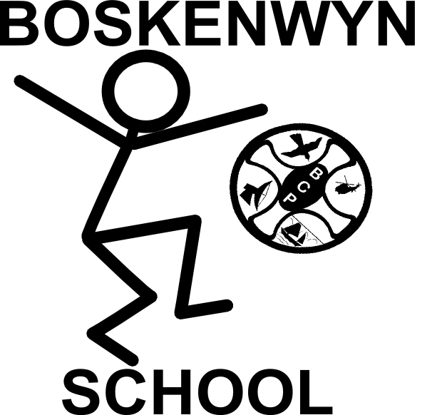
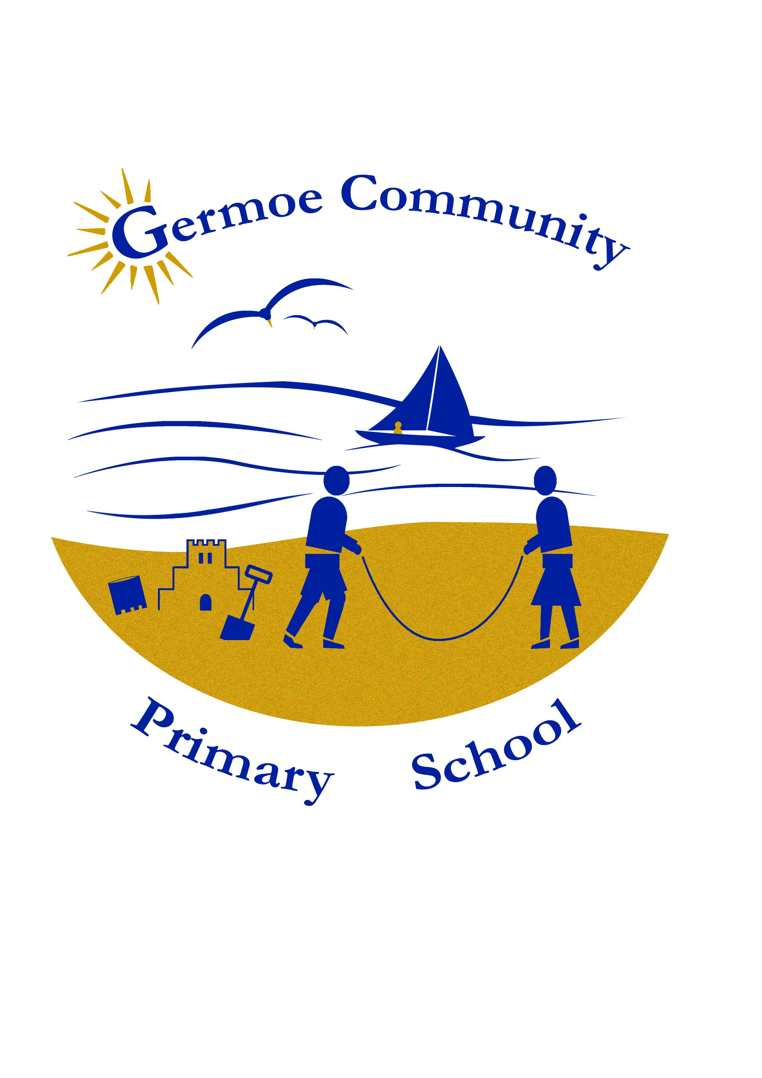

The Federation of Boskenwyn & Germoe Schools

PHYSICAL EDUCATION POLICY

1. Rationale
We believe that PE is the aspect of the curriculum concerned with the development of physical skills, knowledge and understanding in:

Games
Gymnastics
Dance
Athletics
Outdoor Activities
Swimming

PE contributes to the overall education of young people by providing challenges and fulfilment throughout life.

2. Policy Development
This policy was developed following consultation with the Headteacher, staff and lead professionals.

3. Purposes and Aims
The aim of this policy is to clarify and inform all staff, parents, governors, visitors and pupils, how PE is taught at the school.
We aim that all children will:

- participate in at least 2 hours high quality PE and Sport each week and in addition be given the opportunity to participate in extra-curricular clubs.

- be physically active and find enjoyment in Physical activity.

- find a lasting sense of purpose, achievement and fulfilment in physical activity.

- develop physical skills, habits and interest that will promote a healthy lifestyle.

- develop positive attitudes to physical endeavour including perseverance, fair play, team work and sporting behaviour and the ability to cope with success and failure.

- learn how physical exercise affects the body.

- understand the need for safe practice in physical activities, the importance of warming up before any physical activity and know how to achieve these.

4. Equal Opportunities
We believe that all children, irrespective of physical ability, race, gender, creed or stage of achievement have the right to reach their full potential in PE and achieve enjoyment, satisfaction and success at their own level. All children will be encouraged to develop:

- control, co-ordination and an increased range of movement.

- skill and confidence in range of physical activities.

- an awareness of physical capabilities of the body.

- co-operative skills.

- aesthetic and creative ability

5. Definition of PE and content of the curriculum
PE is a foundation subject in the National Curriculum. The fundamental skills, knowledge and concepts of the subject are set out in "PE in the National Curriculum" where they are categorised into 6 areas of activity; games, gymnastics, dance, athletic activities, outdoor and adventure activities, swimming.

6. Areas of Activity
Dance
Dance is an art form which is concerned with developing control, co-ordination and versatility in the use of the body. It helps to maintain flexibility, develop strength and aesthetic awareness and the appreciation of beauty and quality in movement.
Composition, performance and appreciation and evaluation are the four components of dance. All are inter-related and will usually be taught together.
Aims

- to develop control, co-ordination, balance and poise in basic actions of travelling, elevation and stillness.

- to enable children to learn to enrich movements by varying shape, size, direction, level, speed, tension and continuity.

- to experience and respond to a variety of stimuli, including music.

- to explore moods, express feelings and ideas and create simple characters and narratives in movement sequences.

- to create dances with clear beginnings, middles and ends.

- to use techniques and styles to communicate meanings and ideas.

- to give children the opportunity to describe, interpret and evaluate all aspects of dance, choreography, performance and content production.

- to experience examples of traditional/folk dances from different countries.

Games

Games and competitive sports are an essential part of the physical education programme. They involve children participating individually, in a team, co-operatively and are concerned with skills, tactics, principles of play and teamwork.

Aims

- to provide experience of a variety of different games including; invasion games such as football, netball and hockey, net and ball games such as tennis and volley ball, and striking and fielding games such as cricket and rounders.

- to gain understanding of common basic skills and principles, including attack and defence in all types of games.

- to provide games practices that help improve skills.

- to develop own games, rules and scoring systems.

- to experience a variety of roles in each game including umpiring.

- to play and understand small-sided versions of recognised games.

- to learn more advanced techniques and tactics in selected games and how to analyse them in order to improve performance.

Gymnastics

In gymnastics the focus is on the body. We are concerned with acquiring control, co-ordination and versatility. Strength is developed and flexibility is improved. The natural actions involved include, leaping, balancing, inverting, climbing, rolling, travelling and swinging. Pupils work alone, with partners and in small groups, sharing ideas, carefully sharing space and helping one another to lift, carry, place and use apparatus. Pupils will construct, perform and evaluate sequences, alone, with a partner or in small groups.

Aims

- to experience many ways of performing basic actions.

- to improve control of individual actions through repeated practice.

- to learn to link together a series of actions on floor and apparatus and to be able to repeat them.

- to learn how to lift, carry and position apparatus.

- to learn to emphasise elements such as changing shape, speed and direction in a longer series of actions in response to a task.

- to understand and be able to show how body tension, clarity of shape and extension influence quality.

- to understand and develop aesthetic qualities such as contrast, variety and repetition in more complex sequences.

- to demonstrate sequences with or without contact in partner work.

- to learn and be able to analyse more advanced techniques.

Swimming

Swimming is a crucial survival skill and an essential prerequisite for a range of activities in and around water. It provides an excellent form of all round exercise and can contribute to the development of flexibility, strength and stamina. Swimming will take place at Penzance Leisure Centre; all classes swim for two ten week blocks in the Autumn and Spring terms.

Aims

- to develop safety and confidence in the water.

- to know and understand the basic principles of water safety.

- to learn the fundamentals of recognised strokes and a variety of general water skills, and contrasting activities, such as diving, personal survival and competitive skills, and an opportunity to work towards award schemes.

- to ensure that all children at the end of KEY Stage 2 can swim at least 25 metres.
Athletic Activities

In athletics the focus is upon developing a variety of natural physical actions like running, jumping and throwing. The activities provide excellent opportunities for promoting physical fitness and understanding of how the body works. The programme will provide the opportunity for children to work towards the Shine Award Scheme.
Aims

- to experience and participate in running, jumping and throwing activities.

- to develop and practice the basic skills leading to the different athletic events.

- to learn how to measure, compare and improve performance.

- to experience competition.

- to learn about the effects of exercise upon physical health and fitness.

Outdoor and Adventurous Activities

Outdoor and adventurous activities have the potential to satisfy the need for excitement and challenge in a positive way. They also provide opportunities for learning about ourselves and our environment.
Aims

- to explore the potential for physical activities within the immediate environment.

- to undertake simple orientation activities.

- to learn the principles of safety in the outdoors and how to avoid danger.

- to experience at least one exciting and challenging activity in an unfamiliar environment and learn the skills necessary for the activity.

- to experience the need for mutual support/reliance on others in a challenging environment.
7. Planning
Planning in PE is a process in which all teachers are involved wherein termly, weekly and lesson plans are drawn up by individual teachers using the Physical Education lesson plans scheme developed by TOPS, and monitored by the Headteacher.
In planning, the following must be considered:

- warm up/cool down

- differentiation

- depth and breadth of work

- progression and continuity

- evaluation
8. Organisation
The PE curriculum is organised on a subject basis outside the main framework of the curriculum (through dance and gymnastic activities) may be related to topic work. PE is the most firmly timetabled element of the curriculum because of the need to use hall/outside space/venues. PE is taught throughout the school year but not all areas of activity are covered each term.
Within this framework, each class

- spends approx. 2 hours per week on PE/games

- has a weekly swimming lesson at Parc Eglos school during the Autumn Term (except reception children)

- residential outdoor and adventure activities are covered in upper KS2 only during the biennial summer camp to a Cornwall Outdoors Centre.

- children are encouraged to walk to school every Wednesday with walking bus.

- participation in outdoor forest school activities weekly

- children have access to a variety of equipment during outdoor breaks
9. Delivery
Wake Up and Shake Up may be taken by the teachers in rotation in summer term, and Brain Gym in individual classes. Other specialist teachers and coaches are used to deliver sessions to classes and clubs.
In EYFS key stage 1 and key stage 2 PE is taught by the class teacher.
Feedback to pupils about their own progress in PE is achieved and encouraged through discussion between child/teacher in the context of the PE lesson. This is used as assessment.

10. Assessment
At school, we believe that it is crucial to monitor each child's progress in each aspect of the subject and as such, formative assessment is used to determine what each child has learned and what therefore should be the next stage in their learning.
Suitable tasks for assessment include:

- practical tasks directly observed by the teacher.

- small group discussions related to a practical task.

- specific assignments for individual pupils in multi skills – KS1 and KS2 continuity and progression sheets.
Records of children's progress and achievement in PE includes a short assessment at the end of each block of work, and a written report given annually to parents/guardians.

11. Strategies for the use of Resources
All the main PE equipment is stored centrally.
Gymnastic equipment is stored in the hall.
The key for the PE cupboard is kept in the key safe in the office.

12. Health and Safety issues in PE
1. Good discipline.
2. Correct handling of apparatus.
3. Correct clothing and orderly changing.
4. Constant awareness on the part of teachers.
5. Safety during exercise and activity, warm up and cool down (no backwards running at any time).
Clothing - all children should have a change of clothes for PE. Hair should be tied back if it is long enough to fit in a ponytail or if the fringe covers the eyes.

13. Safety Checklist
Before you start.

- are the pupils suitably dressed?

- barefoot for dance and gym.

- trainers/plimsolls for games and athletics.

- have you the teacher changed into suitable footwear?

- have you collected dangerous articles e.g. watches, earrings?

- have you checked long hair is tied back?

- always make sure that any obstructions are out of the way when you are there.

- does a signal immediately produce Stop Look Listen?

- do the children handle equipment with care?

See also PE/Sport procedures
14. Placement
Outdoors - during transportation to and from the Swimming Pool, are the children aware of the need for safety? - Swimming is an enjoyable but potentially hazardous activity. Good control and knowledge of safety procedures is essential.
Indoors- are you keeping clear of all usual obstructions?
Mats should be placed where it is expected that pupils will need to cushion deliberate landings but should not be placed around indiscriminately - only place a mat where you want the children to land!

When you get back:

were there any near misses or collisions?

should you adjust organisation or placing?

first aid kit should be nearby.

Gloves should be worn at all times when dealing with cuts. If any child is unwell or unfit to take part in any PE activity, they must have a letter from their parent/guardian which explains the situation.

In case of an accident, correct procedures must be followed.

Apparatus is checked annually by the local authority to ensure safety in PE.

Links with other agencies enrich the PE curriculum.
These include:

- participation in local sports leagues with other primary schools.

- visits, and liaison with, outdoor education centres and agencies.

- visits from, and liaison with, professional dancers and sports players.

- Parent volunteers
15. Staff Training
Staff will be encouraged to attend courses and review resources. The lead professional will have access to specific training to support and develop their role using delegated budget and sport premium.

16. Dissemination
All staff and governors will be notified of and have access to this policy. A short summary will be included in the school prospectus. The policy and schemes of work will be available on request to parents, LA, OFSTED and others working for the school, through the Headteacher.

17. Reviewing the Policy
Policy reviewed in September 2016
This policy will be reviewed biannually.

…………………………………………………….. ……………………………………………………
P. Quinney, headteacher F. Conway PE Coordinator





