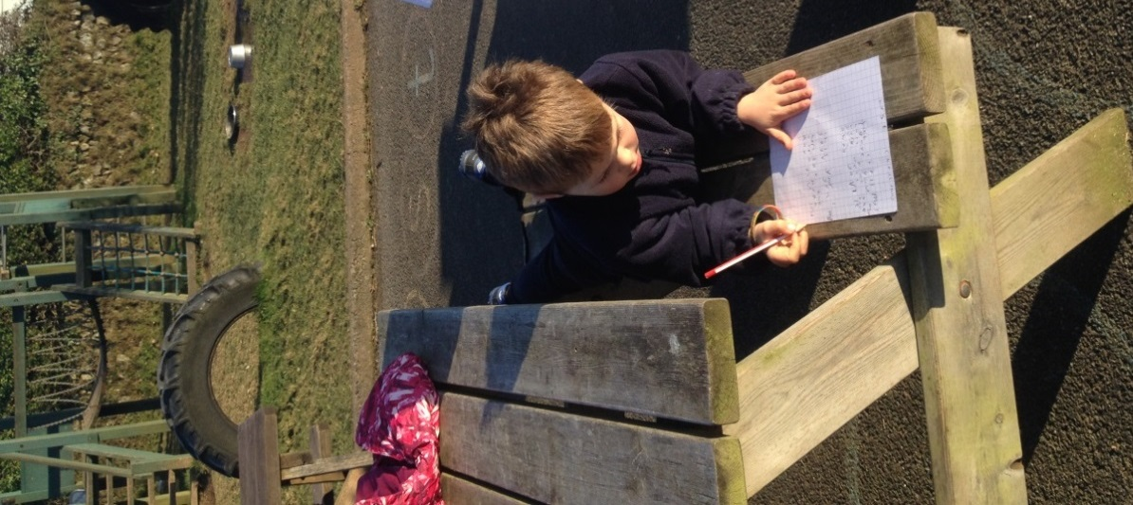
How to support your child’s progress in reading and writing

Hi there,
We have had a few questions from parents about how they can help their child at home, how much help to give with writing homework, and what our expectations are for reading and handwriting. A quick internet search will show just how important parental involvement is in a child making good progress in reading and writing; in fact, the Department for Education says. ‘Parental involvement in a child’s schooling for a child between the ages of 7 and 16 is a more powerful force than family background, size of family and level of parental education.’ So, we thought we’d pop this together to help. We really appreciate all that you do and the great relationship we have with you. Please continue to pop in any time for a chat with your child’s teacher.

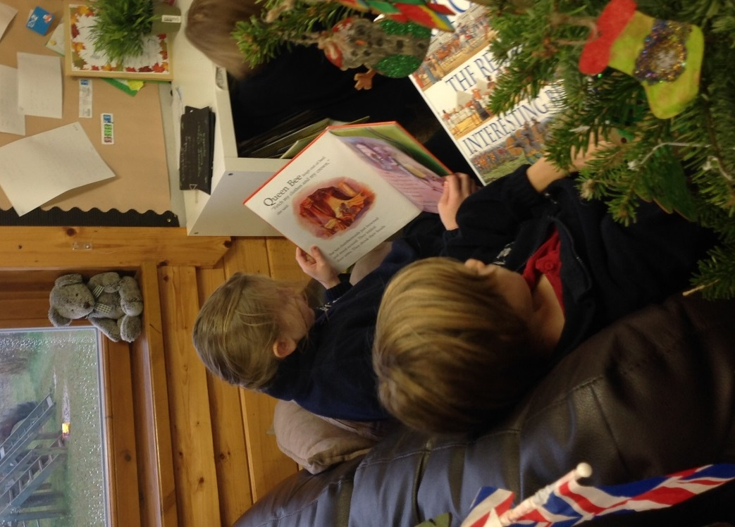
Reading
There is loads you can do to help your child to develop their reading and comprehension skills:
- Encourage your child to read -a lot, anything, anywhere, anytime, and for any length of time;
- Read to/with your child, discussing the story as you go;
- Sign off their home-link book when they have read (this will count towards rewards they receive at school);
- If they are still word building, encourage them to use their phonics and ‘chunk’ longer words into syllables;
- Ask them questions about their books, for example:
- What has happened so far? (Summarising)
- What do you think will happen next? What makes you think that? (Making predictions)
- How do you think ____ is feeling? Why? (Inferring)
- What do you think that word means? (Using context and etymology (word roots) to find out meaning)
- What do wasps eat? When was the great Fire of London? (Retrieving facts from a non-fiction text)
Discussing books with your child enables them to reach a much deeper level of comprehension and helps them to develop their critical thinking skills. Your child’s class teacher will send home a bookmark each half term with some different focus questions on it to help you shape your discussions. They will also always be happy to discuss what they are doing that week in Guided Reading and Phonics sessions.

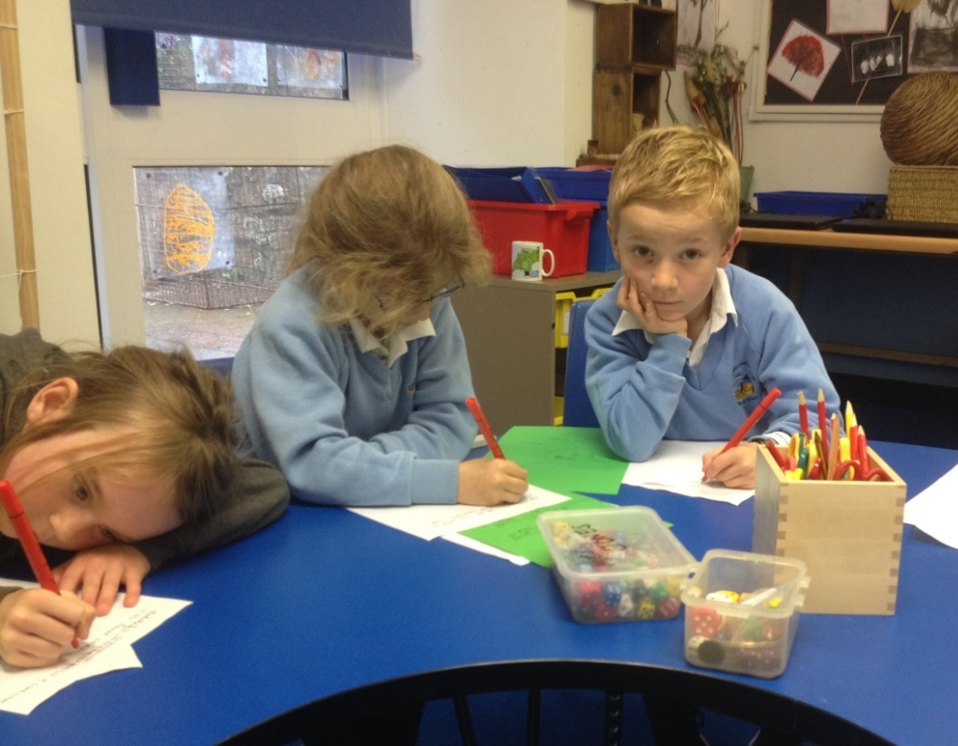
Writing
Sadly, curriculum expectations for writing have changed, placing a much greater emphasis on secretarial skills such as handwriting and spelling. While we will still (obviously) be teaching exciting, inspiring writing, your help in reinforcing those secretarial standards would be appreciated!
- Talk with your child about what they are going to write and what interesting language they could use. This helps them to expand their vocabulary and plan their writing;
- Encourage them to form their letters correctly. We break letters into formation families. ‘Curly Caterpillar’ ones start with a ‘c’ like a, c, o, d, g and q; ‘One-armed Robots’ have the same motion as an ‘r’, starting in the middle and going down-up-and-over, and include r, m, n, p. b and h are honorary members of this group. Long Ladder letters start at the top and go down (t, k and l). Upside-down Umbrella letters start in the middle and go down like i, u, y, w and v. Finally, there is the ‘Odds and ends’ group, including e, f, j, s, x, and z.
- Encourage them to make their letters sit on the line. Capital letters should be big, tall letters should be tall and words should have finger spaces between.
- Once they have finished writing, encourage them to reread it (to you or to themselves) checking that it makes sense and for full stops, capital letters and spellings of common exception words (see attached).
- Have fun!

Websites and APPs
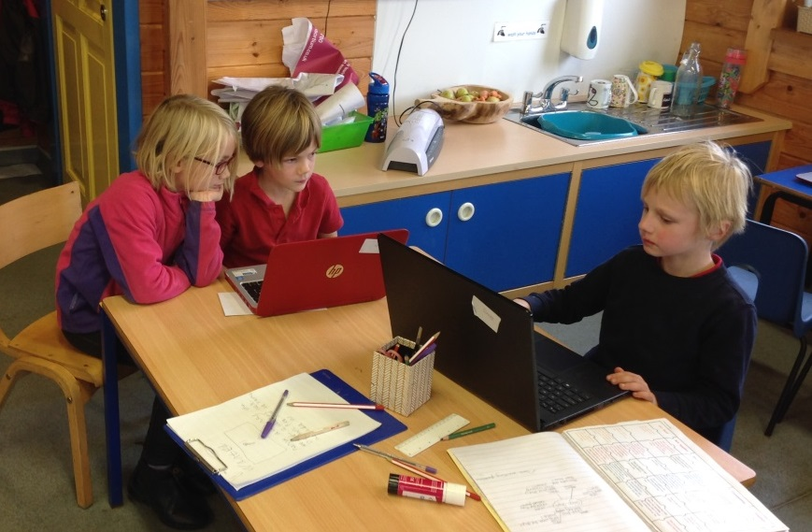

There is so much good stuff out there that it is hard to know where to start, but here goes:

- Oxford Owl is free and has hundreds of e-books as well as a great page for parents.
- Teach my Monster to Read is free and is great for those at the word-building stage of learning to read.
- Nessy is great for learning to read, for those who get muddled with different grapheme choices when spelling, and for any children with dyslexic tendencies. There is heaps of information on there for parents about dyslexia too.
- The National Literacy Trust has a great page for parents recommending the best reading and writing APPs.
- The Talk For Writing website lists the best APPs for story making.
- APPs by Alan Peat and Mr Thorne come highly recommended.
