- Phonics  Can you listen to the ‘e’ sound and practice writing it?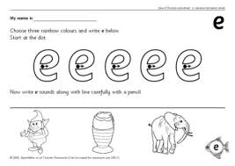 | - Reading  Can you find the eggs with your name hidden around the house? How many did you find? | - Maths  Can you count how many eggs in the basket?
- Writing  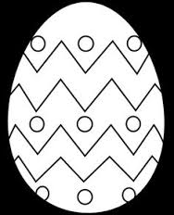  Can you make patterns on your egg? | - Funky fingers  Can you make a 2d shape chick by following the instructions? | 6. My Challenge…

