Week One
Option 1 | Pepperoni Pizza | Chicken Korma | Beef Lasagne | Build your own burger:  Beef  Chicken  Vegetable | Sausage
Option 2 | Rainbow Pizza | Vegetable curry | Vegetarian lasagne |  | Vegetarian Sausage
Sides | Potato wedges  Baked Beans  Sweetcorn | Rice  Broccoli | Garlic Bread  Peas | Coleslaw Nachos  Salad | Chips  Baked Beans  Peas
Dessert | Fresh Fruit | Yoghurt | Jelly or Ice cream | Kathryn’s surprise | Fresh fruit
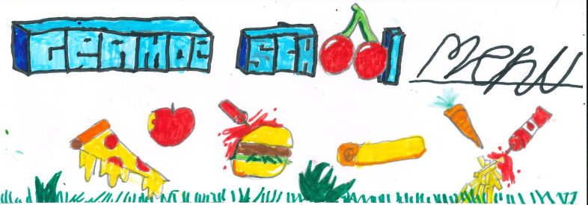

A jacket potato can also be made available each day with either beans or cheese.
If your child has any allergies or dietary requirements that we do not know about please ask for an allergy /diet form from the school office. If your child’s allergies have changed could you please keep us updated.

Week Two
Option 1 | Spaghetti Carbonara | Chicken or chilli beef tacos | Quiche Lorraine | Build your own hotdog:  Meat  Vegetarian | Fish
Option 2 | Vegetarian Carbonara | Vegetarian Chilli | Vegetarian Quiche |  | Quorn Nuggets
Sides | Peas  Sweetcorn | Salad | New potato  Pasta Salad | Coleslaw Salad | Chips  Baked Beans  Peas
Dessert | Fresh Fruit | Yoghurt | Jelly or Ice cream | Kathryn’s surprise | Fresh fruit
A jacket potato can also be made available each day with either beans or cheese.
If your child has any allergies or dietary requirements that we do not know about please ask for an allergy /diet form from the school office. If your child’s allergies have changed could you please keep us updated.

