- Contact Us  Boskenwyn Primary School  Wendron  Helston  Cornwall  TR13 0NG  01326 572618  secretary@boskenwyn.cornwall.sch.uk  Germoe Primary School  Germoe  Penzance  Cornwall  TR20 9QY  01736 763310  secretary@germoe.cornwall.sch.uk |  |  | 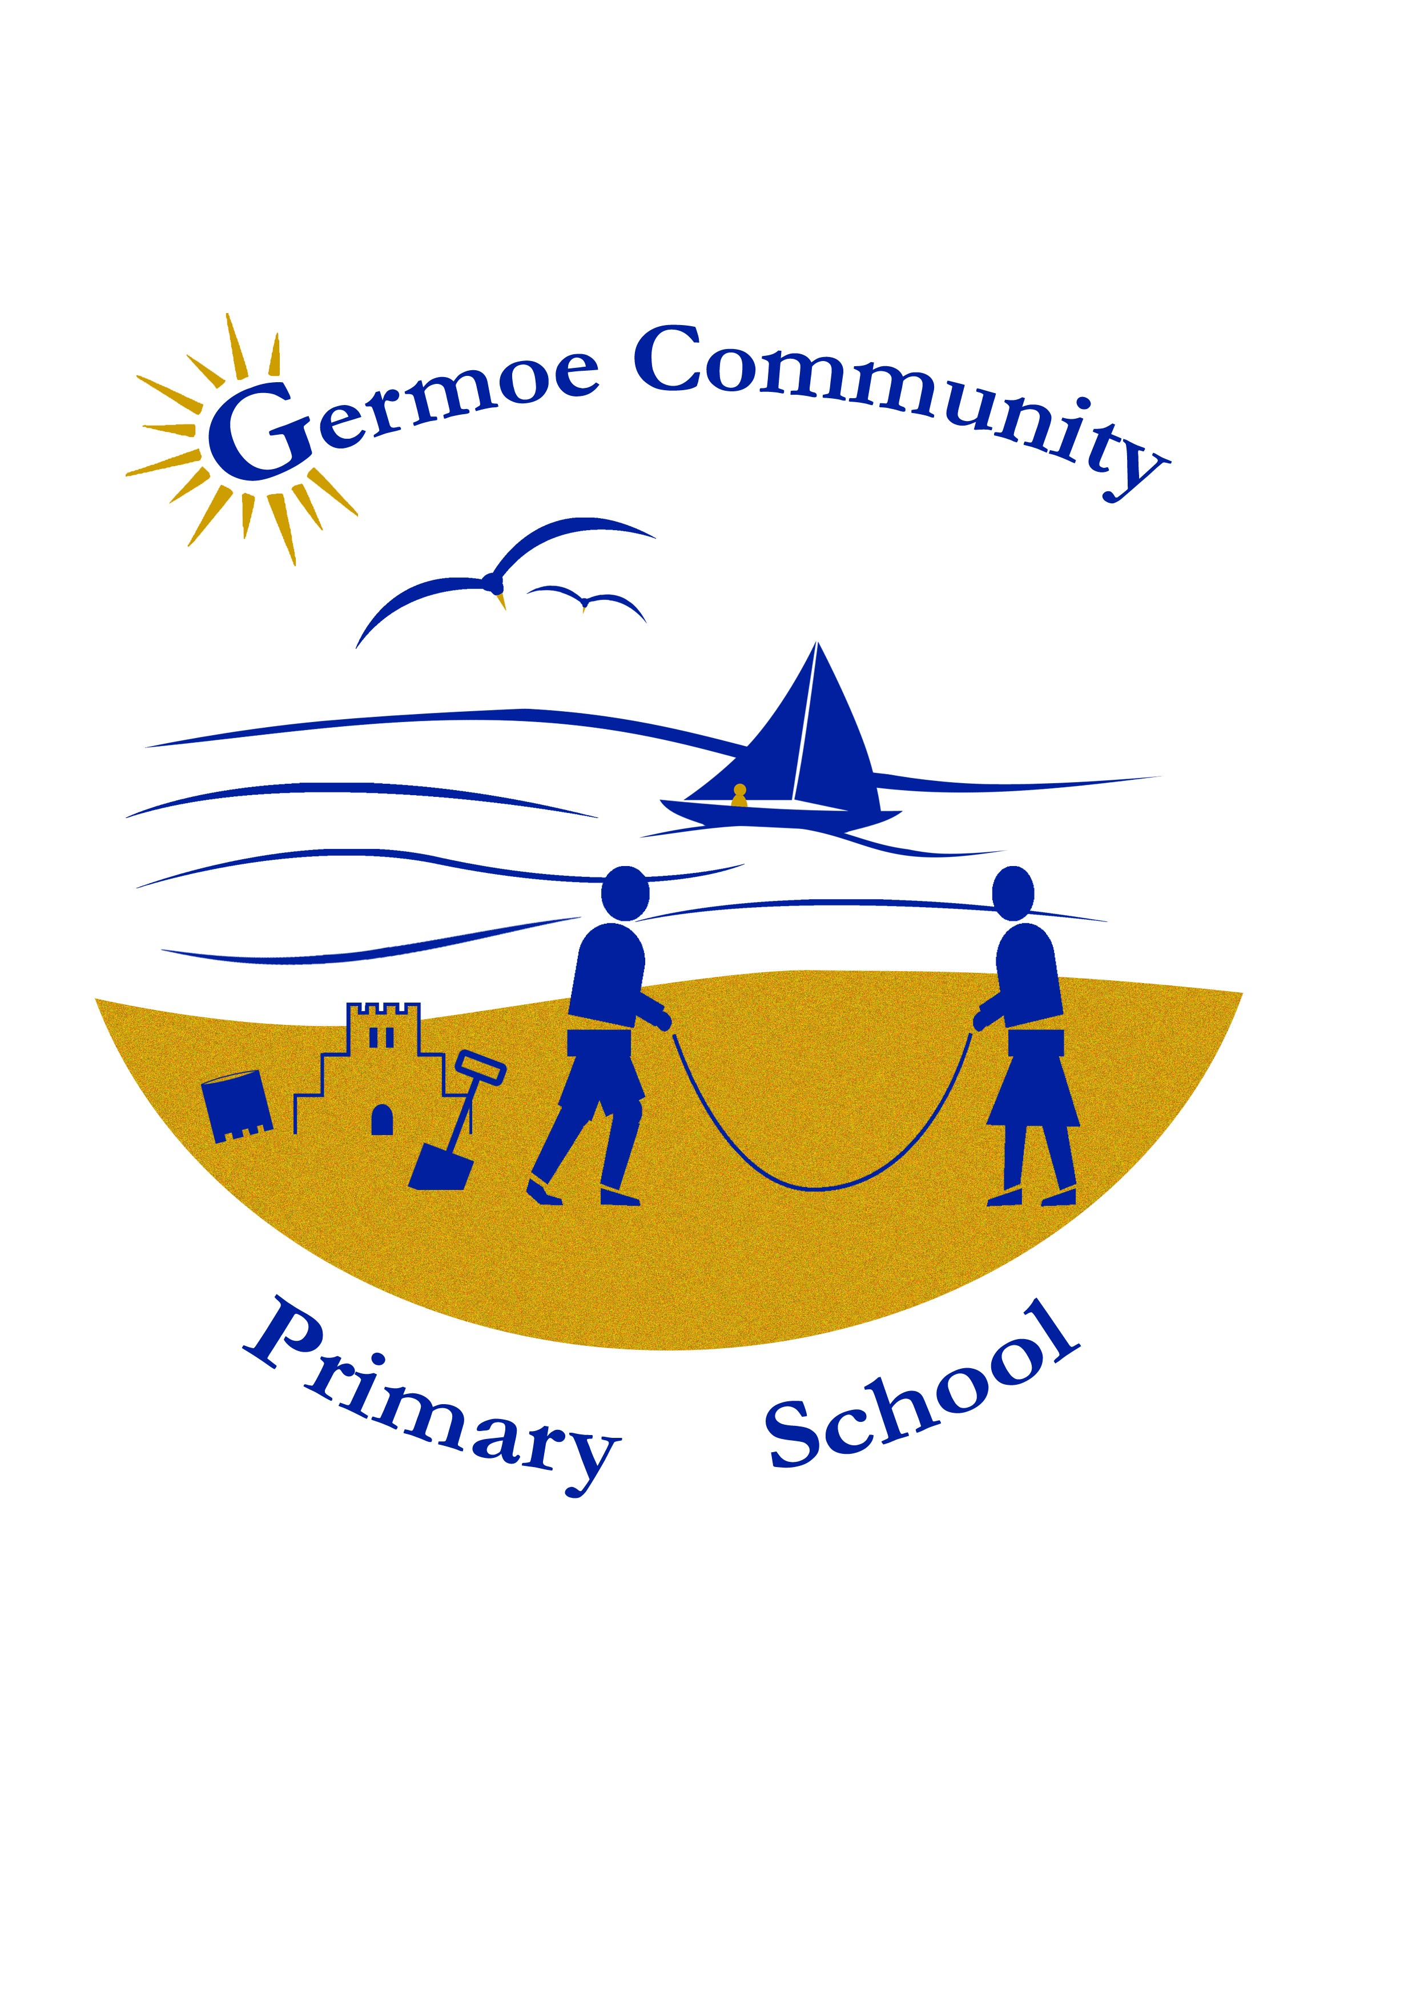  EYFS Maths  for Parents  Federation of boskenwyn and germoe pre-schools and primary schools
Table of Contents  What makes a good mathematician? 1  What does my child need to know in reception? 1  Maths in the Home 2  Maths through play in the home 2  How to help your child at home with maths 4  Maths, Maths, Everywhere! 5 |  |  | Maths, Maths, Everywhere!  Maths is everywhere in the home. With the support of parents, children can grasp and mathematical concepts through their play.  Children will begin to;  - Know and understand early maths language of measurement, shapes, spaces, positions, early numbers, order and patterns.  - Know the sequence of numbers.  - Begin to understand positional words, e.g. in, on, outside.  - Show an awareness of time.  - Be aware of shapes in their environment.  - Be aware of 1 to 1 correspondence  - Acquire new vocabulary.  - Learn number rhymes and songs, e.g. one, two, buckle my shoe.  - Be aware of conservation.  When we say that a child ‘knows their numbers’, what we often mean is that they can recite the names of numbers in ascending order. This is very useful to be able to do, but means very little in itself. Children need to come to know what the number system really means. They can be helped to do this through play.  One of the first things that they need to learn about is conservation – that 3 is always 3 no matter how it is arranged or presented, whether it is the number 3, the letters for three,3 bricks, 3 buttons on a coat or Three Billy Goats Gruff.  Children need to be able to handle real life objects in order to check how many they are and relate this to the number before they can understand numbers for things that can’t be seen in this way such as 3 years old or 3 miles.
 |  |  | 5

How to help your child at home with maths  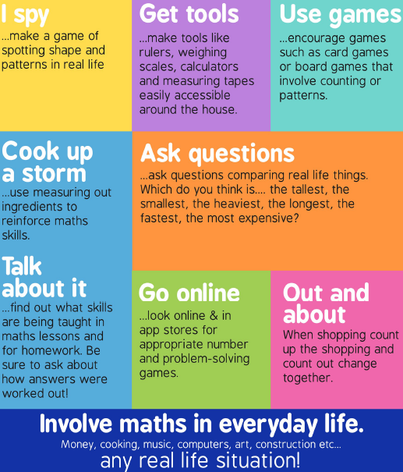 |  |  | What makes a good mathematician?  Number facts  Use & Apply skills and knowledge  Conceptual Understanding  Generalise  Perseverance  Risk-takers  Challenge  Vocabulary  Emotional Resilience  Think Mathematically  Problem Solvers  Fluent Calculators  What does my child need to know?  By the end of their reception year children should have achieved the following Early Learning Goals (ELG) in Maths;  ELG 11 Children count reliably with numbers from 1 – 20, place them in order and say which number is one more and one less than a given number. Using quantities and objects, they add and subtract two single-digit numbers and count on or back to find the answer. They solve problems including doubling, halving and sharing.  ELG 12 Children use everyday language to talk about size, weight, capacity, position, distance, time and money to compare quantities and objects ad to solve problems. They recognise, create and describe patterns. They explore characteristics of everyday objects and shapes and use mathematical language to describe them.
4 |  |  | 1

Maths in the Home  A child’s daily life in the home offer many day to day mathematical experiences and opportunities;  - Handling money when they go shopping with adults.  - Become aware of numbers as they count the stairs to bed.  - Start to understand the concept of time as they become familiar with the routine of their day; wash, dress, breakfast etc.  - Setting places at the table – a cup for you, a cup for me.  - Playing with water and filling containers.  - Steering a pram or bike.  - Helping to sort the washing; matching socks, big shirt/small shirt.  - Tidying up – putting similar items together.  - Matching lids to saucepans.  Maths through play in the home  Here are a few ways in which you can use play to support your child in learning mathematical concepts;  SAND & WATER  - Using sand can help develop mathematical concepts and language, e.g. heavy, light, empty, full, big, little.  - Conservation – how much will it hold?  - Make shapes and patterns.  - Provide boxes and materials of different shapes and sizes too compare weight and quantity.  - Look at the differences between wet and dry as a means of looking at weights.  - Create opportunities to compare things that float with things that do not. |  |  | LANGUAGE  - You can promote mathematical language such as – heavy, light, small, big, little, empty, full, long, short, in relevant contexts.  - Look at your home environment to develop language, especially positional words – small object in front of a bigger object, behind, in, on, next to, in between, top, and bottom.  DOUGH  - Develops mathematical language such as short, long, fat, thing etc.  - Make shapes of different dimensions – flat 2D shapes and 3D shapes.  - Develops children’s fine motor control – provide equipment to experiment with such as forks, butter knives, cutters etc.  IMAGINATIVE PLAY  - Simple activities such as letting your child set the table for meal times can help develop counting skills. E.g. getting out three or four of everything.  - Involve your child with different household activities. After washing allow your child to sort clothes into different colours, or different types of clothing. This will help to develop their knowledge of shapes and colours.  BOOKS & RHYMES  - Enjoys stories and rhymes with your child which have a mathematical content – 10 green bottles etc.  - Let your child count objects in books.  - Rhymes and stories help your child develop their sequencing knowledge.  PHYSICAL  - Develop fine motor skills by doing a jigsaw together or threading beads.  - Block play or playing with cars to develop shape and colour language,  - Tyding toys also helps with sorting and grouping.
2 |  |  | 3

