Incredible Years **for parents of 6 to 11 years olds**

**Free**

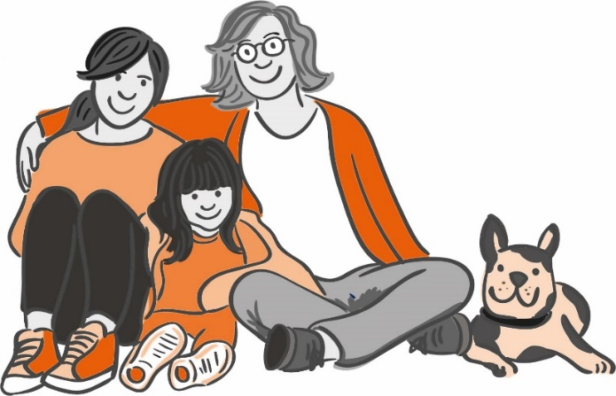

**Sessions include:**

* Child led play
* Understanding behaviours
* Promoting self-esteem and confidence
* Using praise and rewards
* Developing positive and successful

routines

* Strategies and tips to support behaviours that can challenge and much more!

Do you need advice on supporting children’s behaviour?

Further information

Wednesdays 8th September – 8th December (excluding half term) 10:00-11:30

Hayle Family Hub, Bodriggy Street, Hayle, TR27 4ND

To request a place, visit: [www.cornwall.gov.uk/earlyhelphub](http://www.cornwall.gov.uk/earlyhelphub)

Click on ’Request for Help’, then on the request for help form.   
Complete, save and email to [earlyhelphub@cornwall.gov.uk](mailto:earlyhelphub@cornwall.gov.uk)