January 2020

We started off the new year looking at making healthy choices. We talked about eating healthily and looked at the sorts of foods that are good for us. We made some super fruit kebabs in our Funky Friday feast! This theme will continue throughout the term.

The theme for this term is 'Technology, what does it mean to us?'
In Inquiry based learning, we will be exploring different types of technology, including
in the home and all around us. We will be using different ways to record and we will make our own mini films! We will be exploring how things work and how technology is used in everyday life.

Please do keep informed about your child's learning by accessing the Tapestry programme and please add any super learning from home, we love to hear about it!
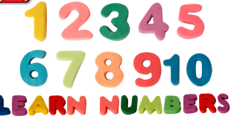
In maths we will be looking at number. We will be counting reliably with numbers from 1 to 10 and recognising the numerals. We will count actions or objects which cannot be moved and select the correct numeral to represent 1 to 10 objects.
We will then go on to Shape, space and measures. Children will use everyday language to talk about size, weight and capacity to compare quantities and objects and to solve problems. We will be ordering two or three items by length or height and by weight or capacity.

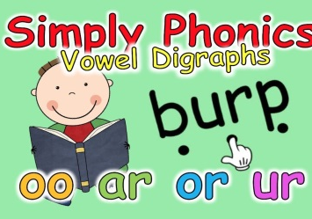
In literacy we will continue to explore set 2 phonic sounds and we will be applying these sounds when writing sentences and captions.:
- Set 2 Speed Sounds: ay ee igh ow oo oo ar or air ir ou oy
- Words containing these sounds
Here is a helpful website for you: https://www.oxfordowl.co.uk/for-home/reading/read-write-inc-phonics-guide-for-parents/

Messy Play
It is within the nature of the Early Years Foundation Stage to have messy play as part of the curriculum, we do ask that the children have a change of clothes, underwear, socks etc just in case of any mishaps. We would be grateful if your child can bring in their own apron/waterproof clearly labelled with their name.
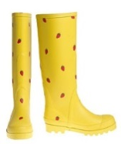
Wellies
Please bring in a pair of wellies to keep in school for wet days and outdoor play and forest school.

Forest school
This will take place on Tuesday afternoons in our lovely forest along with class2. On this day, your child may come to school in old clothes dressed for the forest. We do ask that they wear long sleeves and trousers/leggings to avoid scratches from trees and also bring a pair of wellies.
Funky Friday feast
Every Friday the children have been taking part in the Funky Friday Feast where they make a whole range of delicious food. Tis term we will be concentrating on the process of making the food and the technology involved in doing so. In order to carry on with the Funky Friday feast, we ask for a contribution of 50p a week to help subsidize this. This is a 6 week half term, the cost would be £3.oo, or if you prefer, you can pay 50p a week. The children really do enjoy it, especially the eating! Thank you for your continued support.

