- Phonics  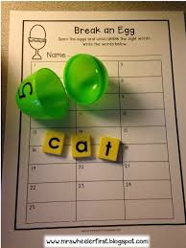  Can you break the egg and make the word? | - Reading  Can you match the rhyming words and read them? | - Maths  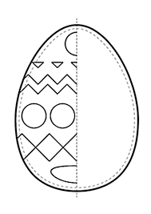  Can you draw the other half of the egg?
- Writing  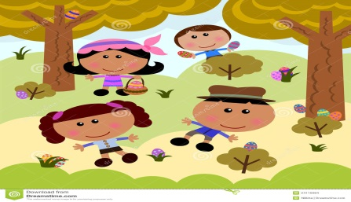  Can you write about your Easter egg hunt around your house and garden? | 5 Funky fingers table  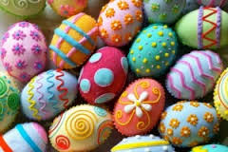  Can you decorate an egg with a pattern? | 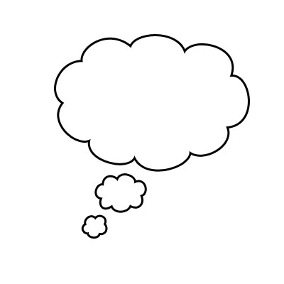  6. My Challenge…

